Earn up to 16% on your travels

Plan how to get there

Find the perfect place to stay
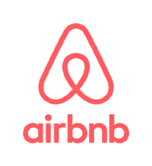
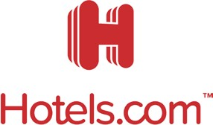

Pack the essentials
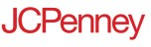

Explore all 750+ brands in the RaiseRightTM app and at RaiseRight.com.

The merchants represented are not sponsors or otherwise affiliated with RaiseRightTM. The logos and other identifying marks used are trademarks of and owned by each represented company and/or its affiliates. Please visit the company’s website for additional terms and conditions. © 2022 RaiseRight

