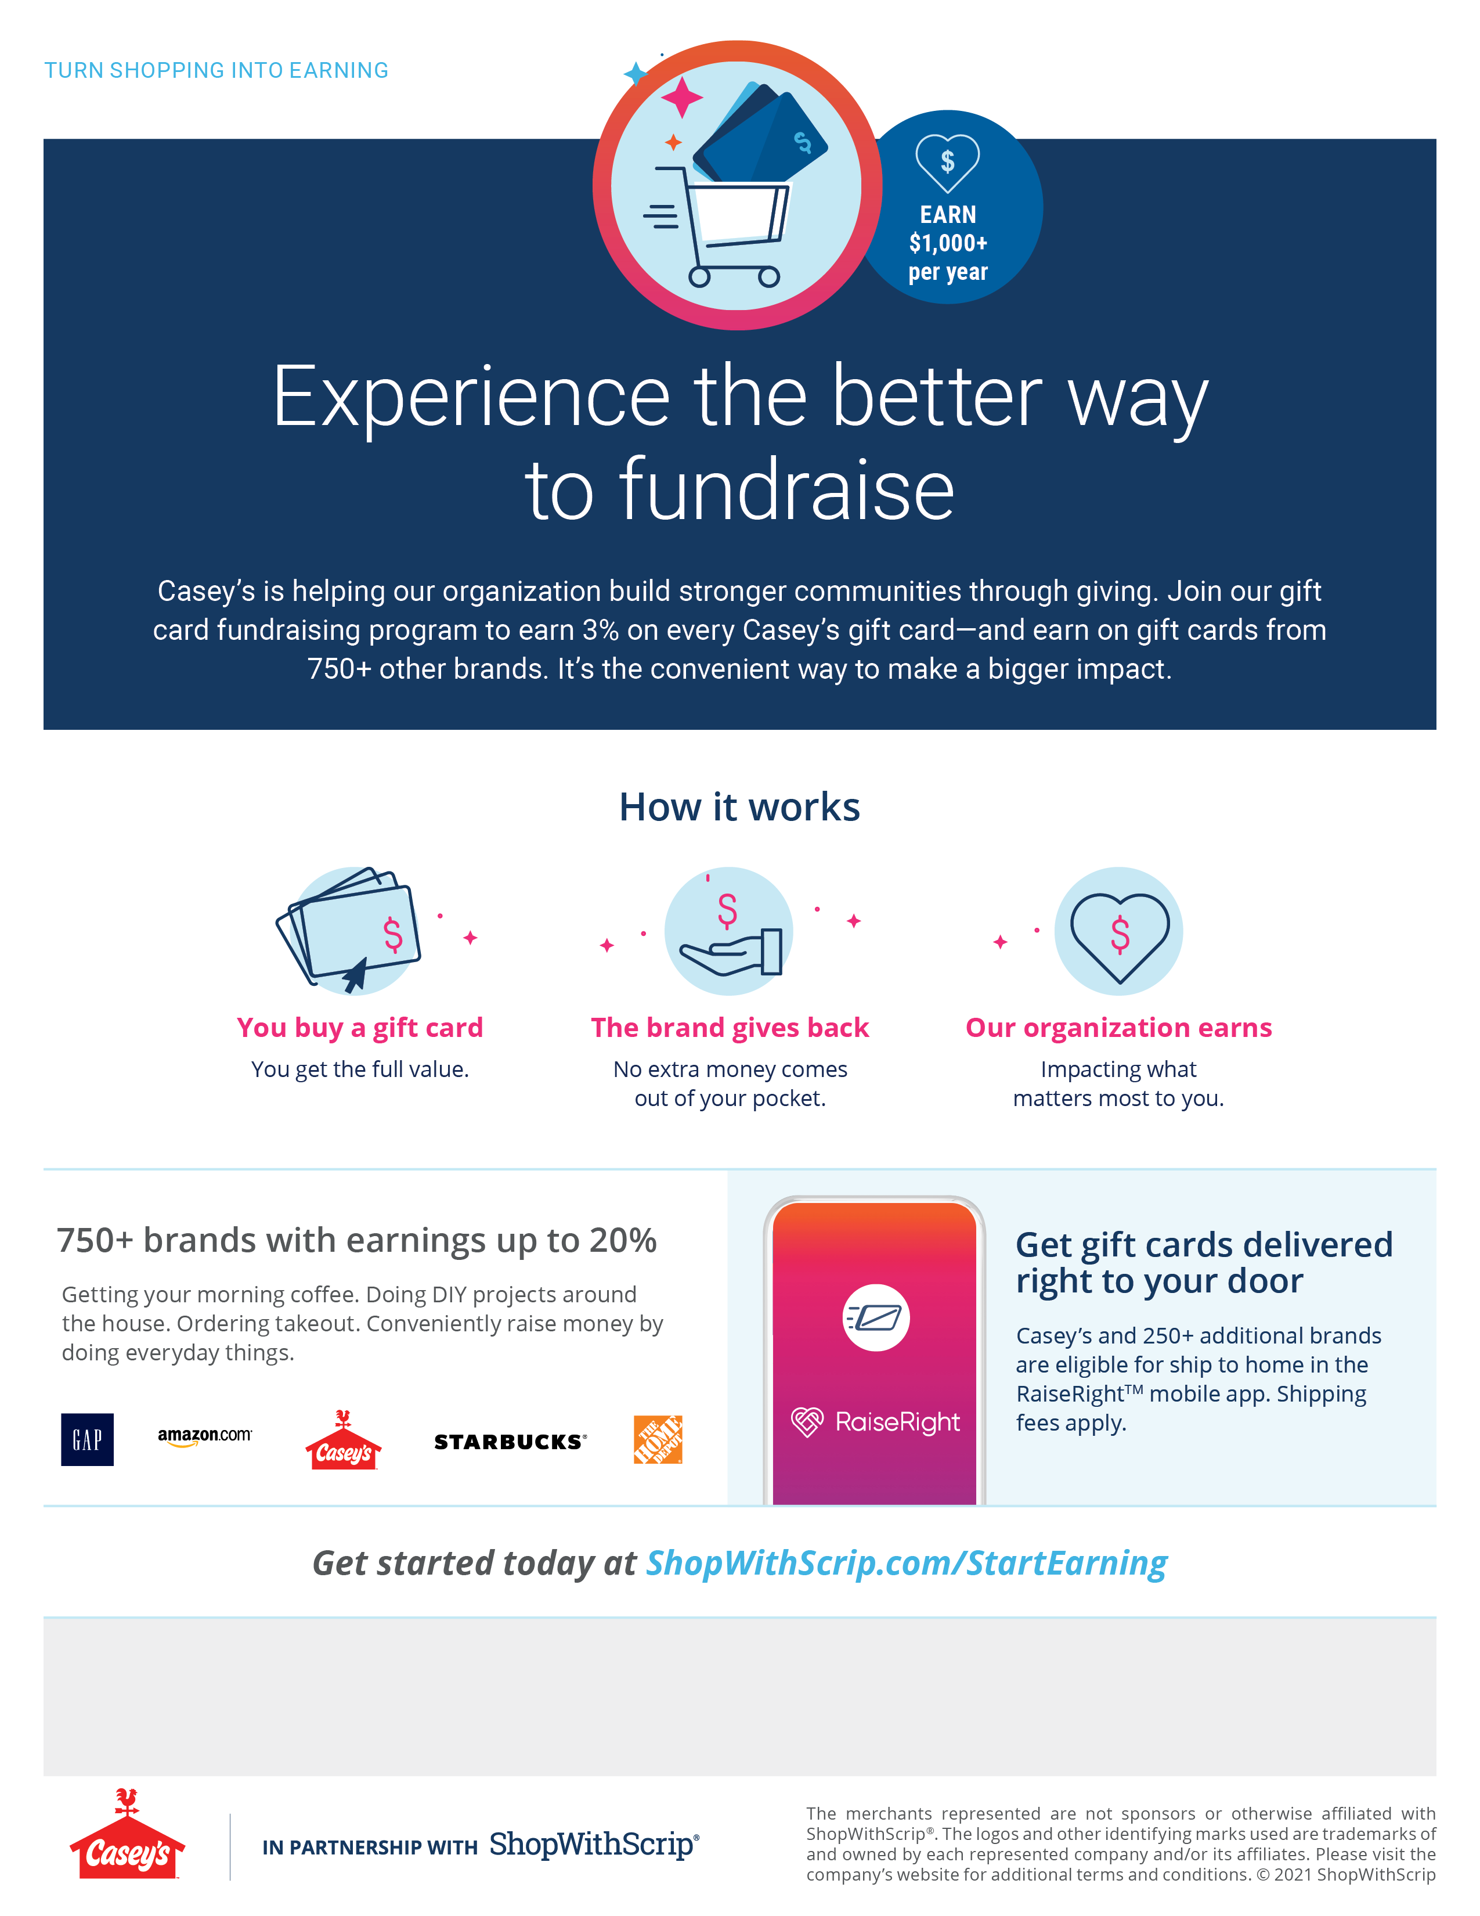

*Use this area for a customized message (e.g. enrollment code, ordering schedule, coordinator contact information, etc.)*